***ZION UNITED CHURCH OF CHRIST Nonprofit Org.***

*402 Main Street* ***U.S. Postage Paid***

*P.O. Box 339* ***Lowden, IA***

*Lowden, IA 52255-0339* ***Permit No. 3***

*Rev .Stephen Stepp, Pastor*

*Church Phone (563) 941-7726*

*Parsonage Phone (563) 941-5476*

# RETURN SERVICE REQUESTED

**2016**

[](http://www.google.com/url?sa=i&rct=j&q=&esrc=s&source=images&cd=&cad=rja&uact=8&ved=0ahUKEwir5v-a5pDLAhUDuYMKHWr9BDIQjRwIBw&url=http://www9.vidowsckoni.tk/wall/easter-jesus-wallpaper/&bvm=bv.114733917,d.amc&psig=AFQjCNHDdoKCRXin23EGZnjiPRtpEUUvqA&ust=1456416967157671)

|  |  |  |
| --- | --- | --- |
| **Community Wednesday Lenten Services** | | |
| **Day** | **Location** | **Preacher** |
|  |  |  |
|  |  |  |
| March 2 | St. Paul’s UCC, Wheatland | David Lorenzen |
| March 9 | First UCC, Tipton | Scott  Meyer |
| March 16 | Zion UCC, Lowden | Tommi Boeder |
| **Worship** – **7:00 p.m.** | **Evening Meal** – **5:00 – 6:30 p.m.**  **\*see the article about our meal on**  **March 16th!** | **Meal prices**  $7.00 for adults  $3.00 for children 10 yrs. and younger |
| Other Lenten Services  **February 10, Ash Wednesday**  Zion / Lowden 7:00 p.m.  **March 24, Maundy Thursday**  St. John’s / Clarence 7:00 p.m.  **March 25, Good Friday**  St. Paul’s / Wheatland 7:00 p.m. | | |

Greetings Sisters and Brothers,

When I was much younger, ok, much, much younger, I learned an important rule about crossing the street. Now, no matter where you live, knowing the right way to cross the street or road can be a vital piece of information that can insure your survival. The rule was simple on its face, but when it was taught to me, there were lots of little nuances that sprouted from the basic three word formula: STOP-LOOK-LISTEN. STOP-don’t leave the curb or edge of the street/road until you finish these rules. Basically, never just walk or run out into the street/road. LOOK-now that you are teetering on the edge, look around you. Do you see a car, truck, bike, or anything moving anywhere near you? Is the crossing light green? Is there a hole in the road where you will be crossing? Basically is there anything that will prevent you from getting across the road or street safely and alive? LISTEN-Seeing is not always good enough because often times we can hear things we cannot see. So listen for cars, trucks, bikes or anything that might prevent you from making it to the other side of the road safely and alive. In today’s world there may be a few enhancements that must be added such as, slow down, the world will not end if we actually STOP. Put your phone, pad, tab or pod away while you LOOK for the things that will prevent you from making it to the other side. Take the ear buds out of your ears and LISTEN for the sounds that might be approaching that will prevent your walk from ending on a happy note.

Now, you may be asking how this simple three word crossing plan has anything to do with faith and Lent? Well, during the Lenten Season, Christians are called to STOP-LOOK & LISTEN too. STOP-and take time with God. Pray, dust off the Bible to read, and contemplate your relationship with God. Basically, don’t just rush through Lent without taking time to find out what God has in store for you. LOOK-now that you are attentive to God’s presence, see what God has planned for you who has accepted the gift of faith and how by following God’s plan as given to you by Jesus Christ, you can avoid the things in this life that may prevent you from finishing your journey. LISTEN-because God’s work in our lives is not always visible. We need to LISTEN intently to our hearts as we are guided by the work of the Holy Spirit and we need to respond to the feelings we receive so we may continue Christ’s work and God’s mission for we are and always will be God’s hands who support the weak, God’s arms who hold the heavy burdened, God’s feet who walk with those during the difficulties of life and God’s heart that loves everyone as if they were our own son or daughter or brother or sister or spouse. May we all follow this simple Lenten practice—STOP-LOOK-LISTEN—as we continue our journey of faith together.

There’s is a lot going on during the month of March, so please read this month’s Herald carefully and keep the calendar handy and get your updated calendar every Sunday during worship. See you in church!

Grace and peace,

Pastor Steve

“As Lent is the time for greater love, listen to Jesus’ thirst…’Repent and believe’ Jesus tells us. What are we to repent? Our indifference, our hardness of heart? What are we to believe? Jesus thirsts even now, in your heart and in the poor -He knows your weakness. He wants only your love, wants only the chance to love you.” **Teresa of Calcutta**

*usher6*

March 6, 2016 Church Council

March 13, 2016 Rick & Karen Bentrott

March 20, 2016 Chelsea Ehlts & Bonnie Kintzel

(Confirmation with 1st communion)

March 27, 2016 Senior High Fellowship @ 6:30 (Communion)

Easter Church council 10:15 (Communion)

April 3, 2016 Church Council

April 10, 2016 Dennis Mostaert & Brett Esbaum

April 17, 2016 Dwight Niermeyer & Bob Fields

April 24, 2016 Senior High Fellowship



March 6, 2016 Kaci Gottschalk & Kelly Proesch

March 13, 2016 Mackenzie Poppe & Kelly Proesch

March 16, 2016 Mackenzie Poppe & Addie Luepker

March 20, 2016 Mariah Behrens & Kaci Gottschalk

March 27, 2016 Addie Luepker & Mackenzie Poppe

April 3, 2016 Kelly Proesch & Mariah Behrens

April 10, 2016 Addie Luepker & Kaci Gottschalk

April 17, 2016 Mackenzie Poppe & Mariah Behrens

April 24, 2016 Kelly Proesch & Kaci Gottschalk

**MC900359797[1]**

March 6, 2016 Aaron Horman

March 13, 2016 Donna Luepker

March 20, 2016 Cheryl Boedeker

March 27, 2016 Cody Fields



***MARCH BIRTHDAYS***

March 1 Mallory Baldwin,*Amanda Kahl,

Elaine Mae Coppess

March 4 Doug Wiedenhoff, Jamie Nabb,

Lisa Gottschalk

March 5 Lonnie Luepker

March 8 Tanya Stewart

March 9 Jalynn O’Howell

March 10 Carolee Lohman

March 11 Gene Horman, Annette Behrens,

Kody Klahn, Seth Hamilton

March 12 Dennis Mostaert, *Lisa Horman

March 13 Megan Horman

March 14 *Lisa Gottschalk

March 15 Aaron Horman, Anna Welch

March 18 Addison Luepker

March 19 KaCee Traver

March 22 Parker Stout

March 23 Sandra Koch

March 25 Paige Hamilton

March 26 Carrie Fox

March 27 Donna Tank

March 30 Kent Stout, Heidi Neill, Dean Behrens

March 31 Dorothy Fisher, Jennifer Glover

***MARCH BIRTHDAY CARD SHOWER***

Dorothy Fisher, Wheatland Manor, P.O. Box 369

Wheatland, Iowa 52777-0369

*MARCH ANNIVERARIES*

March 5, 1960 Alden & Marilyn Klahn

March 10, 1956 Merle & Donna Tank\

March 14, 1992 Scott & Carman Fields

March 21, 2008 Brandon & Jessie

March 29, 2009 Josh & Jennifer Horman

Lenten Dinner at Zion

Zion Evening Circle will provide a delicious meal before the Lenten Service at our church on Wednesday, March 16th.

The meal will be served from 5:00 to 6:30 p.m. Come and enjoy our Beef Lasagna or Chicken Lasagna with a Tossed Salad, Garlic Bread, Beverage and Dessert. The cost will be $7.00 for adults; $3.00 for children 12 and under.

The Lenten Service will begin at 7:00 p.m.

# Luke 9:23

Then Jesus said to them all:

“Whoever wants to be my disciple must deny themselves and take up their cross daily and follow me.”

C:\Users\ZionPastor\AppData\Local\Microsoft\Windows\Temporary Internet Files\Content.IE5\7O6MB771\MC900048271[1].wmfDECORATE THE CHURCH

WITH SPRING FLOWERS FOR

EASTER 2016

Janis Krafock, Donna Luepker and Marlene Wiedenhoff are in charge of the Easter flowers this year. They will be taking orders beginning February 28 and March 6 at church and we need your order by Wednesday March 9. The prices are for Easter Lilies 6” pot for $10, 2 plants 8” Pots for $20, Azaleas 6” pot for 21, Mum 6 ½ pot for $14 , Hydrangeas 6 pot’ for 22, and Tulips, Hyacinths, or Daffodils 6”pot for $13.“ Thank you



Mark your calendars hungry Brothers and Sisters!!!

On April 3, 2016, we will be having our annual Spring Dinner at Zion United Church of Christ. As this date approaches, the committee would like to thank all who have so generously donated their time, talents and resources so that this community mission event may be enjoyed by all.

Perhaps you missed the sign-up sheets, do not fret! There is still time for you to be involved by simply calling on one of the committee members. Maybe you like surprises and are waiting for us to delegate a job to you. In either event there will be lots of fun to be had by all.

In 2016, the Spring Dinner Committee plans to streamline the work load of our mission event. On Saturday, April 2nd a portion of the meal preparations will take place along with setting up the dining room and ensuring an ample supply of electricity for the roasters. The committee will be working on Saturday starting at 9:00 am and invite 6 more volunteers to help. There will be some grilling involved and we know some our men and women like to grill. So if you would like to join us, please let us know and we will put you on the schedule. Oh and by the way, if you work on Saturday you will have off on Sunday. It is a win, win. This year the menu will be:

**Swiss Steak**

**Mashed Potatoes with gravy**

**French Cut Green Beans and Corn**

**Mandarin Orange Cookie Salad and Pasta Salad**

**Chocolate Lasagna or Cherry Cheesecake**

**Rolls with butter and a beverage**

**For our children 12 and under, we will be serving a Pasta Bake free of charge**

With God’s blessing and our Zion church family working together as one body in Christ, we will be fruitful in our mission.

With hearty appetites,

Your Spring Dinner Committee



**Zion**

**United Church of Christ**

**Church Council Meeting Minutes**

**February 16, 2016**

Zion United Church of Christ Council met at 6:30 p.m. on February 16, 2016. The meeting was called to order by President David Niermeyer. Pastor Steve opened with a reading and a prayer. Those in attendance were Pastor Steve, Jamie Nabb, Tanya Stewart, Bonnie Kintzel, David Niermeyer, Merlin Conrad, and Pete Johnson. Linda Behrens was in attendance thru the treasurer’s reports. Julie Hoffmeier and Jane Drewelow were present for the technology training.

Aaron Horman demonstrated how to operate the new stereo sound system iPad and run the projector screen computer. “Thank You Aaron!!!”

Joys and concerns were shared. News and happenings were announced.

Secretary’s minutes from Church Council Meeting January 12, 2016 were read, corrected and approved on a motion made by Merlin. Second by Bonnie, Motion carried.

The treasurer’s general fund was reviewed and approved. A motion was made by Merlin and second by Pete. Motion carried. All remaining monthly financial reports were reviewed and approved, on a motion made by Bonnie and second by Pete. Motion carried.

**Calendar Review:** March 2nd St. Paul’s UCC Wheatland Lenten Service.

March 6th Christian Ed Family Fun Night at 4:30 to 7:00 p.m.

March 9th First UCC Tipton Lenten Service

March 16th Zion UCC Lowden Lenten Service with evening meal

March 20th Confirmation/Palm Sunday

March 24th Maundy Thursday St. J John’s Clarence at 7:00 p.m.

March 25th Good Friday St. Paul’s Wheatland at 7:00 p.m.

March 27th EASTER

April 3rd Spring Dinner

Pastor’s report was read and approved on a motion made by Pete, second by Jamie. Motion carried. Discussion topic. What person or story in th Bible do you relate to best and why? Dinner for eight will be delayed a little bit due to family and organizational obligations.

**Old Business**

Insulation project completed and paid

Roof is finished and paid.

**New Business**

Jamie presented Spring Dinner updates

Light bulb to be changed north sanctuary.

Insulation removed from the organ chamber per Darren Ferreter. Everything remains in good working condition.

Office lock needs fixed.

Outside light need changed over ramp and by the Deerberg Door.

**Committee reports**

Music and worship met January 24th. Scripture readers have the choice of assisting throughout the service with Call to Worship, Prayer, etc.

Suggestions received for a building a stage for ZYC performance during worship.

Mission is hosting a chili and chicken noodle Soup Luncheon this Sunday, February 21

Free will offering.

Pastoral Relations meets February 23rd

Spring Dinner’s next meeting February 25th.

Next meeting Tuesday, March 15, 2016 at 7:00 p.m.

Pastor Steve closed with a prayer.

Meeting adjourned with a motion by Bonnie, second by Jamie. Motion carried.

Tanya Stewart

Secretary

**Zion’s**

**Family Fun Night**

**Sunday, MARCH 6, 2016**

**4:30PM – 7PM**

***Fun, food, & faith in one family night***

**MC900198164[1]**

**Make plans to join uS!**

**Event hosted by the Christian education program**

**everyone is welcome!!!**





ZION EVENING CIRCLE

**February 15, 2016**

Jean led devotions entitled Acorns, Pumpkins and God and Crack-Pot to begin our evening on February 15, 2016. Lynn Butterbrodt then spoke to us about her process of writing her book “Words in a Journey of Care”. She was both inspiring and interesting as she told her story. Jean, filling in for Janice S., and Rose served refreshments.

Our business meeting began with Pastor Steve and 17 members attending. The secretary’s report was read and approved. The treasurer’s report was read and approved. A motion by Millie, 2nd by Marlene W. to pay bills was made and approved.

Donna thanked Jean for leading devotions and those who took care of flowers for January and February.

Terry reminded us of the Lenten Supper which we will serve on March 16th.

Plans for selling spring flowers were discussed by Marlene W. Orders will be taken on Feb. 28th and March 6th. Altar flowers were also discussed.

Pastor Steve reminded us of the Mission Committee’s soup luncheon to be held Feb. 21st and that the Confirmands will be reading their faith statements on Feb. 28th.

Serving the Committee on Ministry in March will be Millie and Janis K.; March devotions will be by Sharon; Carolee and Jean will provide refreshments. Elaine Mercado will be our special speaker about the Orphan Train. Flowers for March will be taken care of by Marlene W., Donna and Janis K.

Sharon Elijah, Secretary

Secretary

**Missions Committee Meeting**

The Missions Committee met Sunday, October 4, 2015 following church services. Members in attendance were Linda Behrens, Carmen Fields, Tanya Stewart, Beth Kahl, Marlene Wiedenhoff, Mary Huffman and Rev. Steve Stepp.

Pastor Steve opened with a prayer.

Linda called the meeting to order and noted that Jessica Coppess will also be joining our committee.

Minutes from the previous meeting were read and approved.

Our current balance is $6,352.03. Linda noted that we have two CD’s and asked if we should cash in the smaller CD to supplement the fund. Following a brief discussion, it was decided to wait until we actually need additional fund before cashing it in.

Linda reported that the Missions contribution from the current envelope have been deposited in the Zion Mission account, but that these funds were meant for the OCWM (Our Churches’ Wider Mission). It was moved by Mary and seconded by Tanya to reimburse OCWM and to add the Zion Mission to the envelopes, if that’s possible. Motion carried.

Discussion was held regarding holding a chicken and noodle and chili soup luncheon. February 21 was selected as the date. Linda will check with Little Home Daycare and the Fire Station to assure there are no conflicts. We will meet at the church at 9:00 on the 20th to make soup and set up tables. Responsibilities are as follows:

Mary: Two pans of bars and shredded cheese

Beth: Chicken Soup and crackers

Linda: Chili and Milk

Carmen: Two pans of bars

Marlene: Cheese tray and bread

Jessica: Bars or cookies

Members should keep track of their expenses and will be reimbursed as necessary.

The next meeting date will be April 17, 2016.

Carmen moved and Tanya seconded to adjourn the meeting.

Pastor Steve closed with a prayer.



**Flowers for the Alter in Church**

Enclosed in the Herald is a form to designate flowers in honor of or in memory of someone you love. If you would like to give flowers, please fill out the form and drop it in the offering plate, drop it by the office, or mail it to church. On that Sunday, we will have an announcement printed in the worship service bulletin. You may purchase the flowers and bring them to church yourself, or you may call Linda in the office and arrange delivery. Thank you.

**LIST OF USHER FOR WORSHIP SERVICE 2016**

**APRIL3, 2016 CHURCH COUNCIL**

APRIL 10, 2016 Dennis Mostaert & Brett Esbaum

April 17 ,2016 Dwight Niermeyer & Bob Fields

April 24, 2016 Senior High Fellowship

**May 1, 2016 Church council**

May 8, 2016 Dean & Mandi Behrens

May 15, 2016 Wilbert & Millie Muhs

May 22, 2016 Brenda Esbaum & Sharon Kruckenberg

May 29, 2016 Senior High Fellowship

**June 5, 2016 Church Council**

June 12, 2016 Jess & Debra Axline

June19, 2016 Al & Vicki Mohr

June 26, 2016 Senior High Fellowship

**July 3, 2016 Church council**

July 10, 2016 Cheryl Boedeker & Donna Luepker

July 17, 2016 Donavon & Linda Freese

July 24, 2016 Rick & Mary Balke

July 31, 2016 Senior High Fellowship

**August 7, 2016 Church Council**

August 14, 2016 Tim Kahl & Jared Bentrott

August 21, 2016 Tim & Jane Drewelow

August 28, 2016 Senior High Fellowship

**Sept. 4, 2016 Church council**

Sept. 11, 2016 Duane & Terry Lasack

Sept.18. 2016 Judy Proesch & Lori Dittmer

Sept. 25, 2016 Senior High Fellowship

**October 2, 2016 Church Council**

October 9, 2016 Jessica Coppess & Annette Behrens

October 16, 2016 Lou & Janis Krafock

October 23, 2016 Barry & Julie Hoffmeier

October 30, 2016 Senior High Fellowship

**Nov. 6, 2016 Church Council**

Nov. 13, 2016 Beth Fox & Tessa Holst

Nov. 20, 2016 Kent & Janice Strackbein\

Nov. 23, 2016 Thanksgiving Eve-Bill & Sharon Elijah

Nov. 29, 2016 Senior High Fellowship

**Dec. 4, 2016 Church Council**

Dec. 11, 2016 Rose Horman & Mary Huffman

Dec.18, 2016 Kent & Janice Strackbein

Dec. 24, 2016 Scott & Carmen Fields

Please mark your calendar with your date so you know when it is your turn. You will not be receive a card to remind you. Thank you.

**Senior High Fellowship**

Senior High Fellowship met on Sunday, January 31st after church. The attendees were Pastor Steve, Cody Fields, Jacob Holst, Tessa Fields, Grace Proesch, Makayla Schluter, and Avery Luepker. Kyle Proesch provided the wonderful meal and Grace Proesch gave the prayer and devotional. President, Cody Fields, called the meeting to order. All old business was discussed. A food/toiletry drive through the school was planned for February 19th - 25th. All proceeds will go to local church food pantries. Also, It was decided that the members of Senior High Fellowship are going to invite confirmands into SHF on Confirmation Day. The next meeting is on February 28th with parents for planning Easter Breakfast and the Sunrise service. After the meeting Grace Proesch, Avery Luepker, Makayla Schluter, Tessa Fields, and Pastor Steve baked cookies and made Valentine’s Day cards for church members in nursing homes and shut ins. They plan to deliver them on Valentine's Day.

Tessa Fields SHF Secretary

Christian Education News:

**Thank you** everyone who supported our **Annual Bake Sale**! Our proceeds were $304.75 and this year we will donate this to the Ronald McDonald House in Iowa City. Our eldest Sunday School Class will be taking a mission trip to the Ronald McDonald House on Wednesday, March 9th. They have made tie blankets for families and plan to help prepare a meal for families staying at the Ronald McDonald House while family member(s) are at the University of Iowa Hospitals.

We have a **FAMILY FUN NIGHT** planned for Sunday, March 6 from 4:30pm – 7:30pm. The night is for everyone of ALL ages! We will begin with table activities; enjoy some pizza; salad; garlic bread; and dessert bars for dinner followed by some fun interactive activities in the Christian Education Basement. Please come and join the festivities for a fun night out this winter! We will need a few volunteers to help in the kitchen for dinner and to make a pan of dessert bars of your choice. A sign up will be found in the Narthex outside of the sanctuary. Any questions please contact Kelly Nabb (563) 249-2335.

**EASTER** is fast approaching with many reasons to celebrate! First, we celebrate confirmation with our confirmands Mariah Behrens, Addison Luepker, Kaci Gottschalk, Mackenzie Poppe, and Kelly Proesch on ***Palm Sunday***. Palm Sunday is March 20; please come together to celebrate these young ladies and all of their accomplishments. We then celebrate EASTER on March 27th. Sunday School Classes will be at the normal time – 9:00AM. There will be two worship services this morning; a Sunrise followed by a SHF Breakfast and a 10:15 Worship Service. Join us for the celebration of Easter and the ultimate gift of sacrifice of Jesus Christ.

**REMEMBER TO MARK YOUR CALENDAR**

March 2, 2016 7:00 p.m. Lenten Service At St. Paul’s Wheatland with meal being served from 5:00 to 6:30 p.m.

**March 5, 2016** **Christian Education Family Fun Night From 4:00 to 7:00 p.m.**

March 9, 2016 7:00 p.m. Lenten Service at First UCC

in Tipton, with Pastor Meyer preachin. Their meal will be served from 5:00 to 6:30 p.m.

March 16, 2016 7:00 p.m. Lenten Service at Zion UCC

Lowden, preaching Pastor Boeder. Meal will be served from 5:00 to 6:30 p.m.

March 20, 2016 **CONFIRMATION SUNDAY,**

**at 10:15 p.m.**

March 24, 2016 7:00 p.m. Maundy Thursday worship service at St. John’s in Clarence.

March 25, 2016 7:00 p.m. Good Friday service at St. Paul’s in Wheatland.

**March 27, 2016 EASTER SUNDAY**

6:30 a.m. Easter Sunrise Service with Breakfast to follow.

10:15 a.m. Easter Service



Confirmation Sunday is

Palm Sunday, March 20th

during the 10:15 am worship service.

The members of the 2016 Confirmation Class are…

Mariah Behrens

Kaci Gottschalk

Addison Luepker

Mackenzie Poppe

Kelly Proesch

We hope that you will come and support our confirmands as they take their confirmation vows to God.

Thank you everyone.

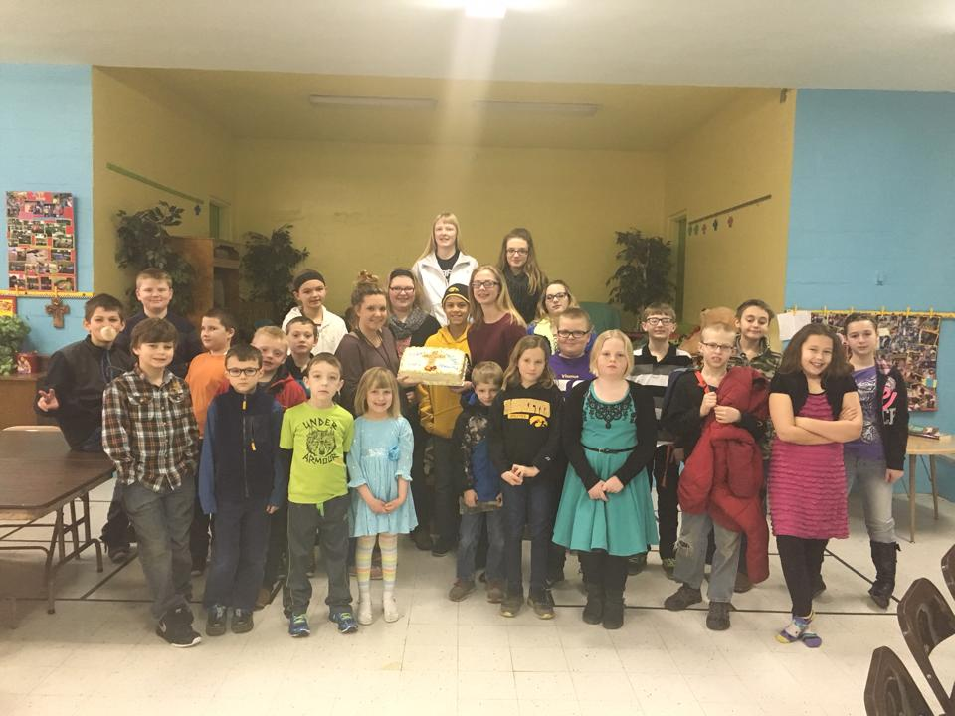

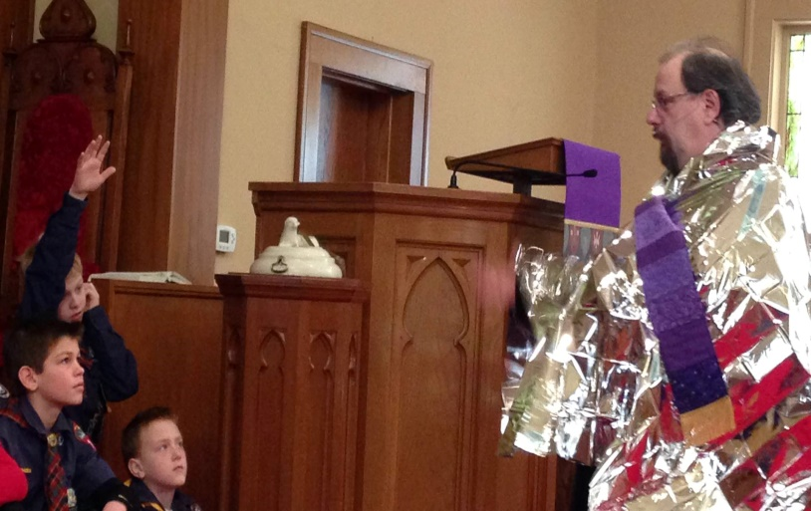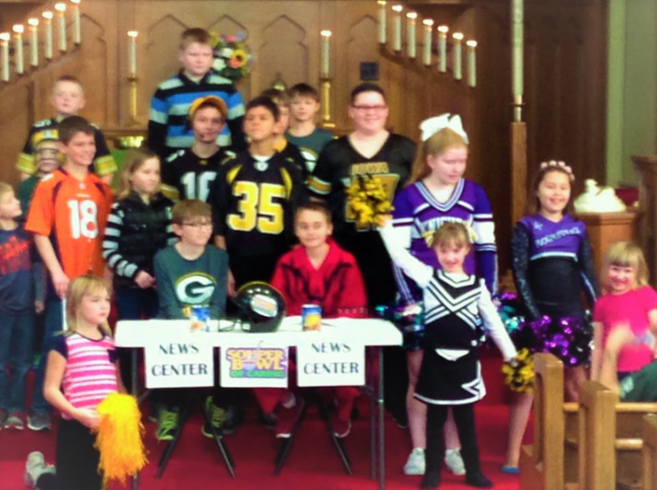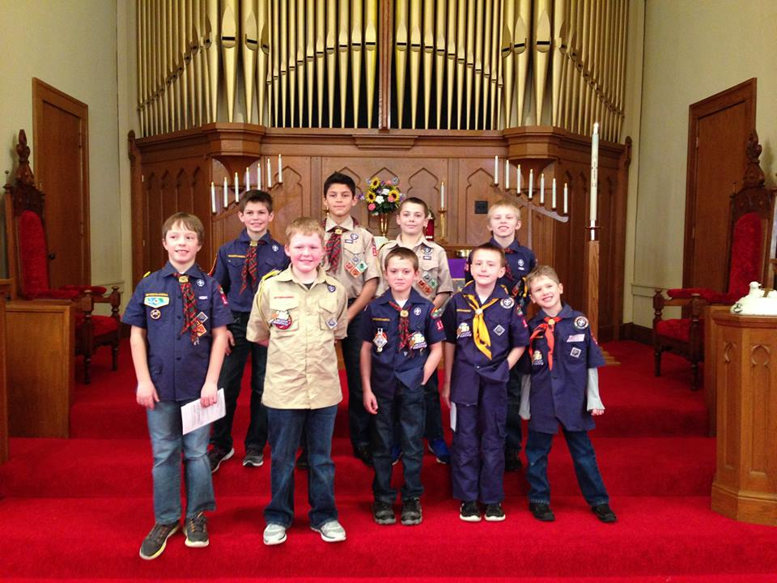

|  |  |  |  |  |  |  |
| --- | --- | --- | --- | --- | --- | --- |
| Sunday | Monday | Tuesday | Wednesday | Thursday | Friday | Saturday |
| March 2016 |  | 1 | 2 | 3 | 4 | 5 |
|  |  |  | 9:00 am North Cedar Clergy Stanwood  Lenten service at St. Paul’s UCC in Wheatland. Meal |  |  |  |
| 6 | 7 | 8 | 9 | 10 | 11 | 12 |
| C. E. Class at 9:00  Worship service at 10:15  REMEMBER  Family Fun Night |  |  | Confirmation Mission Trip  Lenten service at First  UCC in Tipton. Meal is from 5:00 to 6:30 p.m. Pastor Meyer Preaching | 10:00 a.m. Wheatland Manor Nursing Home Service |  |  |
| 13 | 14 | 15 | 16 | 17 | 18 | 19 |
| Christian Education  Class at 9:00  Worship service at 10:15 |  | 7:00 p.m. Zion Church Council | 3:30 to 5:30 p.m. ZYC Meeting  Lenten service at Zion UCC here. Meal served from 5:00 to 6:30 p.m. Pastor Meyer preaching |  | . |
| 20 | 21 | 22 | 23 | 24 | 25 | 26 |
| PALM SUNDAY  CONFIRMATION & FIRST COMMUNION at Worship Service at 10:15 a.m.  Christian Education  Class 9:00 am | Evening Circle meeting @ 7:00 p.m. with guest speaker |  | Herald articles are due  E.C.I. Meeting at 8:30 a.m. | Maundy Thursday Service at St. John’s Clarence at 7:00 | Good Friday worship service  At St. Paul Wheatland @ 7:00 p.m. |  |
| 27 | 28 | 29 | 30 | 31 |  |  |
| **EASTER SUNDAY**  6:30 A.M. Easter Sunrise Sunday, Easter breakfast to follow worship  10:15 a.m. Worship 9:00 C.E. Classes | Spring Renewal UDTS | Spring Renewal UDTS | Herald Articles are Due  3:30 to 5:30 p.m. ZYC Meeting  Spring Renewal UDTS |  |  |  |